

SINDH MADRESSATUL ISLAM UNIVERSITY (SMIU) DEPARTMENT OF SOFTWARE ENGINEERING(SE)

FALL 2026

COURSE TITLE: INTRODUCTION TO DATA SCIENCE
SEMESTER/SECTION: BSSE – 6B
COURSE CODE: CSC 218
INSTRUCTOR: MS. LARAIB WAHEED

Lab 4
Exploring Pandas Functions: groupby(), apply(), and sort_values()

Objective
To understand and perform data analysis using advanced pandas functions:
- groupby() for data grouping and summarization
- apply () for applying custom or built-in functions
- sort_values() for sorting data efficiently

Introduction:
1. groupby()
Definition:
The groupby() function in pandas is used to split data into groups based on one or more column values.
It allows you to perform aggregate operations like sum(), mean(), count(), etc., on each group separately.
Purpose:
It helps summarize large datasets and find trends or totals within specific categories.
Syntax:
df.groupby('column_name')['target_column'].aggregate_function()
Example:
df.groupby('Category')['Total_Sales'].sum()
This groups all rows by “Category” and calculates the total sales in each group.

2. apply()
Definition:
The apply() function is used to apply a custom function to each element, row, or column in a DataFrame or Series.
It provides flexibility to perform complex operations beyond built-in functions.
Purpose:
It is helpful when you need to transform or modify column data using a formula, function, or lambda expression.
Syntax:
df['column_name'].apply(function_name)
Example:
df['Discounted_Sales'] = df['Total_Sales'].apply(lambda x: x * 0.9)
This applies a 10% discount to each Total Sales value.
3. sort_values()
Definition:
The sort_values() function is used to arrange the data in ascending or descending order based on one or more columns.
Purpose:
It helps organize data for analysis or presentation, such as ranking top sales or sorting products alphabetically.
Syntax:
df.sort_values(by='column_name', ascending=True)
Example:
df.sort_values(by='Total_Sales', ascending=False)
This sorts data by Total Sales from highest to lowest.

Lab Tasks:
Step 1 – Load the Dataset
You will use the Sales Dataset (sales_data.csv).
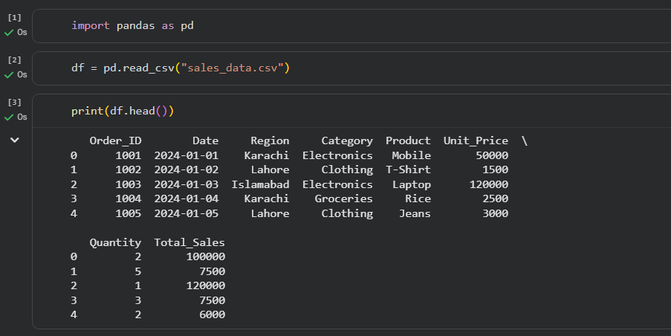
Step 2 – Using groupby()
Calculate Total Sales per Category
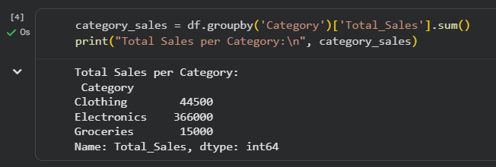
Calculate Average Unit Price per Product
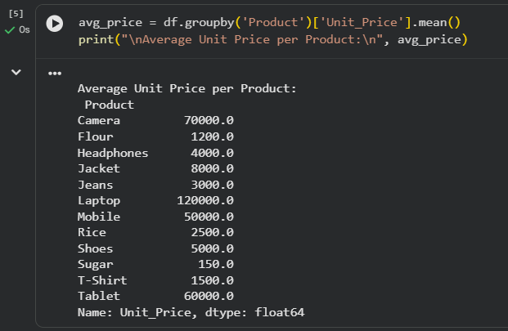
Step 3 – Using apply()
Add a new column showing Discounted Sales (10% off):
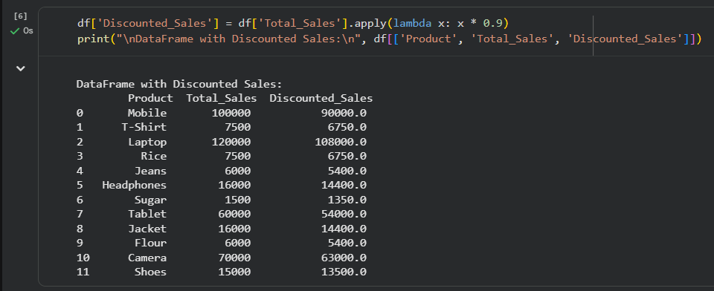
Step 4 – Using sort_values()
Sort the dataset by Total Sales (Highest to Lowest)
